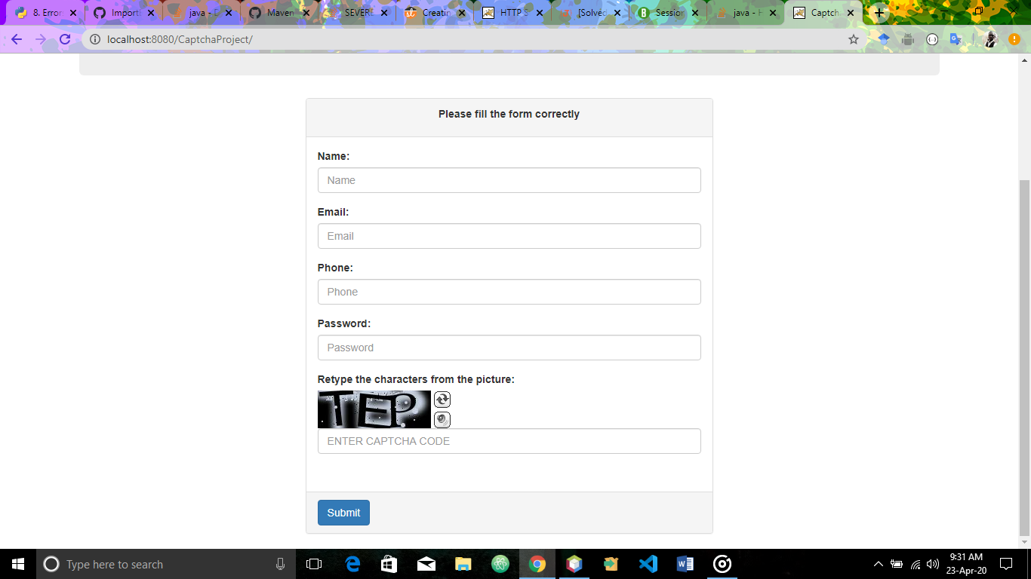

**Landing page with Captcha**

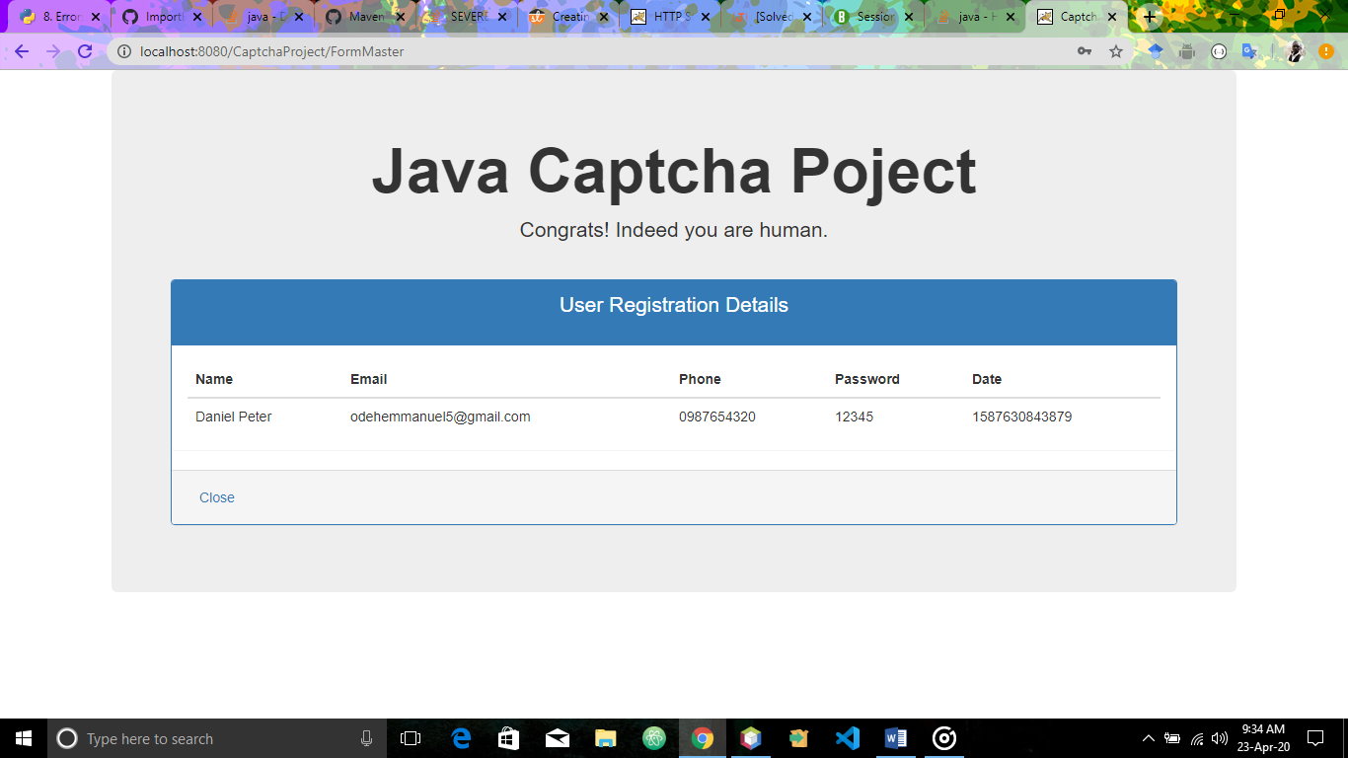

**Completed Registration page with user details**

**NB:** The captcha code is dynamic and random, it changes every time the page is loads or is refreshed.